**SMART STAR EXAMINATIONS BOARD**

**END OF TERM I EXAMINATIONS - 2024**



MATHEMATICS

**PRIMARY ONE**

***Time Allowed: 2*** *hours* ***30*** *minutes*

**Name...........................................................Stream............**

**INSTRUCTIONS**

1. ***Avoid unnecessary crossing of work.***
2. ***Use very good handwriting.***

**SECTION A**

1. **Add:**
2. 7 + 2 = ________________
3. + = ___________
4. **Fill in the missing numbers.**
5. 2, _____, 4, _____, 6
6. 9, _____, 11, _____, 13
7. **Circle the correct number word.**

3 = three , theer, treeh

8 = eigth, eight, gieth

1. **Name these sets.**

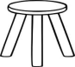  A set of _________



A set of __________

1. **Arrange numbers starting with the smallest.**
2. 6, 3, 4, 2 ______________________________
3. 14, 12, 15, 10 ___________________________
4. **Join the sets correctly.**



+ =

__________ + _________ = ___________

1. **Ring the smaller number**.
2. 8 and 9
3. 12 and 20
4. a) How many days make a week**?**

_________________________________________

b) **Fill in correctly;**

Fr ___ day

S __ nday

1. **Complete the abacus.**

**T O**

**T O**

4 1

1. a) Trace the shape below.

b) Name the shape.

___________________________________

1. Use the sets below to answer the questions.

**Set RSet S**

1. Set **S** has _________ members.
2. Set **R** has ___________ members.
3. Count and match.

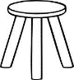

4

6

5

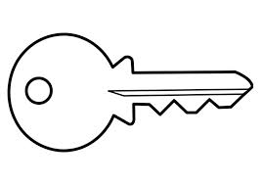

8

1. **Tell the time.**

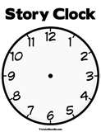

It is __________ O’clock.



It is __________ O’clock.

1. **Take away.**
2. 8 - 4 = ___________________
3. 5

- 4__

_____

1. **Draw these shapes**.

|  |  |  |
| --- | --- | --- |
|  |  |  |
| kite | oval | rectangle |

1. **Form small sets from the big set**.

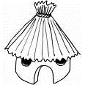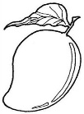

1. **Draw more objects to complete for the numbers.**

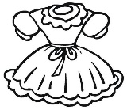

3 = ____________________

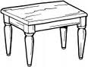

5 = _____________________

7 = __ ______________

1. **Write in words**.

2 _____________________

4 ______________________

1. **Draw these sets.**
2. A set of**4** brooms.
3. A set of **3** stones.
4. **Write the number between**.
5. 12,_____, 14
6. 1, ______, 3
7. Study the picto graph below and answer the questions.

|  |  |
| --- | --- |
| Sam | C:\Users\Robinah\Pictures\doll.jpgC:\Users\Robinah\Pictures\doll.jpg |
| Joy | C:\Users\Robinah\Pictures\doll.jpgC:\Users\Robinah\Pictures\doll.jpgC:\Users\Robinah\Pictures\doll.jpgC:\Users\Robinah\Pictures\doll.jpgC:\Users\Robinah\Pictures\doll.jpg |
| Loy | C:\Users\Robinah\Pictures\doll.jpgC:\Users\Robinah\Pictures\doll.jpg |
| Keith | C:\Users\Robinah\Pictures\doll.jpgC:\Users\Robinah\Pictures\doll.jpgC:\Users\Robinah\Pictures\doll.jpg |

**Questions.**

1. Keith got ____________ dolls.
2. Who got the biggest number of dolls**?**

__________________________________________

1. ________ and ________ got the same number of dolls. **END**